**SINUSOIDAL SIGNALS**

**LAB # 0****6**

**Spring 2023**

**CSE-301L**

**Signals & Systems Lab**

Submitted by: **AIMAL KHAN**

Registration No.: **21PWCSE1996**

Class Section: **A**

“On my honor, as student of University of Engineering and Technology, I have neither given nor received unauthorized assistance on this academic work.”

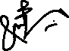

Student Signature: ______________

Submitted to:

**Dr. Durr-e-Nayab**

Monday, April 17, 2023.

Department of Computer Systems Engineering

University of Engineering and Technology, Peshawar

**CSE 301L: Signals & Systems Lab**

**LAB ASSESSMENT RUBRICS**

|  |  |  |  |  |  |
| --- | --- | --- | --- | --- | --- |
| **Criteria & Point**  **Assigned** | **Outstanding**  **(5-4)** | **Acceptable**  **(4-3)** | **Considerable**  **(3-2)** | **Below Expectations**  **(2-1)** | **Score** |
| 1. **Attendance and Attentiveness in Lab** (PLO10) | Attended in proper  Time and attention in Lab | Attended in proper  Time but not attentive in Lab | Attended late but attentive in Lab | Attended late not attentive in Lab | 5 |
| 1. **Capability of writing Program/ Algorithm/ Drawing Flow Chart** (PLO1, PLO2, PLO3, PLO5) | Right attempt/ no errors and well formatted | Right attempt/ no errors but not well formatted | Right attempt/ minor errors and not well formatted | Wrong attempt | 5 |
| 1. **Target Achievement/ Results/Outputs in Lab** (PLO9) | 100% target has been completed and well formatted. | 75% target has been completed and well formatted. | 50% target has  Been completed but not well formatted. | None of the  outputs are  correct | 5 |
| 1. **Overall Knowledge** (PLO10) | Demonstrates excellent  knowledge of lab | Demonstrates good  knowledge of lab | Has a partial idea about the Lab and  procedure followed | Has a poor idea about the Lab and  procedure followed | 4 |
| 1. **Attention to Lab Report** (PLO4) | Submission of Lab Report in Proper Time i.e. in the next day of lab., with proper documentation. | Submission of Lab Report in proper time but not with proper documentation. | Late Submission with proper documentation. | Late Submission Very poor  documentation | 10 |

**Instructor: Dr. Durr-e-Nayab**

Signature: ______________________

**Sinusoidal Signals**

Objectives:

In this lab, we will cover the following topics:

* Generating Sinusoids
* Addition of Sinusoids with Variation in Parameters and their Plots
* Linear Phase Shift Concept When Dealing With Sum of Sinusoids

Task # 01:

Generate the 1x10 row vector *v* whose *i*‐th component is cos (iπ/4).

Code:

clc;

clear;

close all;

vector = 0;

for i = 1: 10

vector(i) = cos(i * pi /4);

end

vector

Output / Graphs / Plots / Results:

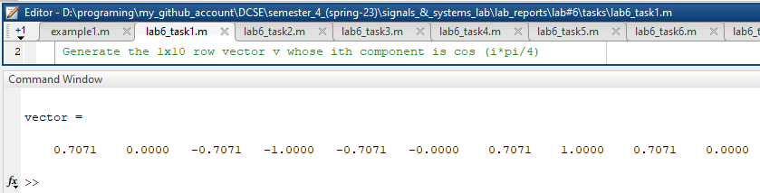

Task # 02:

Write matlab code that draw graphs of sin (nπx) on the interval ‐1≤x≤1 for n = 1, 2, 3, …, 8.

(Hint: Use for loop)

Code:

clc;

clear;

close all;

x = -1: 0.005: 1;

for n = 1 : 8

sig = sin(n * pi * x);

figure(1);

subplot(2, 1, 1);

plot(x, sig, 'm');

xlabel('time --sec--');

ylabel('Continuous Signal');

title('Graph of sinosoid');

subplot(2, 1, 2);

stem(x, sig, 'g');

xlabel('time --sec--');

ylabel('Discrete Signal');

title('Graph of sinosoid');

end;

Output / Graphs / Plots / Results:

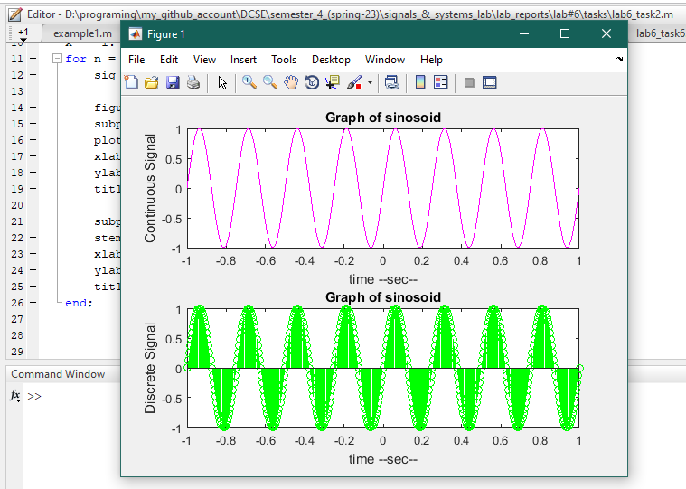

Task # 03:

Given the signal exp(‐x)sin(8x) for 0≤x≤2π, plot its continuous‐time and discrete‐time representations. Use subplot and label properly.

Code:

clc;

clear;

close all;

x = -1: 0.005: 1;

sig = exp(-x) * sin(8 *x);

figure(1);

subplot(2, 1, 1);

plot(x, sig, 'm');

xlabel('time --sec--');

ylabel('Continuous Signal');

title('Graph of sinosoid');

subplot(2, 1, 2);

stem(x, sig, 'g');

xlabel('time --sec--');

ylabel('Discrete Signal');

title('Graph of sinosoid');

Task # 04:

Modify the example given in topic 6.2 to generate a sine wave with phase shift of +pi/2. Then plot a cosine wave of same frequency, amplitude, and phase shift of 0 in another subplot. Compare both the signals and determine the relationship between the two.

Code:

clc;

clear;

close all;

% a) First signal

fs = 1000;

time = -3: 1/fs : 3;

Amp = 2;

phase1 = pi / 2;

freq = 1;

sig1 =Amp * sin(2 * pi * freq * time + phase1);

% b) Second signal.

phase2 = 0;

sig2 =Amp * cos(2 * pi * freq * time + phase2);

% Plotting the graphs.

figure(1)

subplot(2, 1, 1);

plot(time,sig1, 'm', 'linewidth', 1.5)

title('Continuous-Time Sine Wave: A sin(2*\pi*f*t +\phi)') ;

xlabel('Time Index --sec--')

ylabel('Signal Amplitude')

axis([time(1) time(end) -Amp Amp])

grid

subplot(2, 1, 2);

plot(time,sig2, 'r', 'linewidth', 2)

title('Continuous-Time Cos Wave: A cos(2*\pi*f*t +\phi)') ;

xlabel('Time Index --sec--')

ylabel('Signal Amplitude')

axis([time(1) time(end) -Amp Amp])

grid

Output / Graphs / Plots / Results:

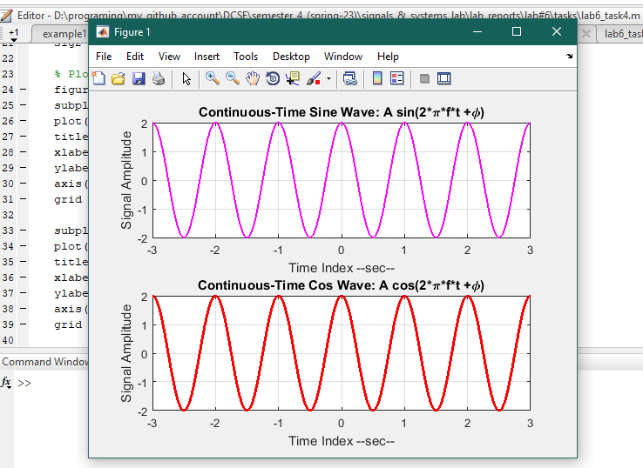

Task # 05:

Write a program to generate a continuous‐time sine wave of frequency 3 Hz, positive phase shift of pi/2, and amplitude of 5. Also generate a continuous‐time cosine wave of frequency 3 Hz, amplitude of 5, and phase shift of 0. Plot the two signals on separate subplots and properly label them. Determine the relationship between the two signals.

Code:

clc;

clear;

close all;

Amp = 5;

freq = 3;

time = -1 : 1 / 1000: 1;

phase1 = pi / 2;

phase2 = 0;

sig1 = Amp * sin(2* pi * freq * time + phase1);

sig2 = Amp * cos(2 * pi * freq * time + phase2);

% Plotting the graphs.

figure(1)

subplot(2, 1, 1);

plot(time,sig1, 'g', 'linewidth', 1.5)

title('Continuous-Time Sine Wave: A sin(2*\pi*f*t +\phi)') ;

xlabel('Time Index --sec--')

ylabel('Signal Amplitude')

axis([time(1) time(end)-1 -Amp-2 Amp+2])

grid

subplot(2, 1, 2);

plot(time,sig2, 'r', 'linewidth', 2)

title('Continuous-Time Cos Wave: A cos(2*\pi*f*t +\phi)') ;

xlabel('Time Index --sec--')

ylabel('Signal Amplitude')

axis([time(1) time(end) -Amp Amp])

grid

Output / Graphs / Plots / Results:

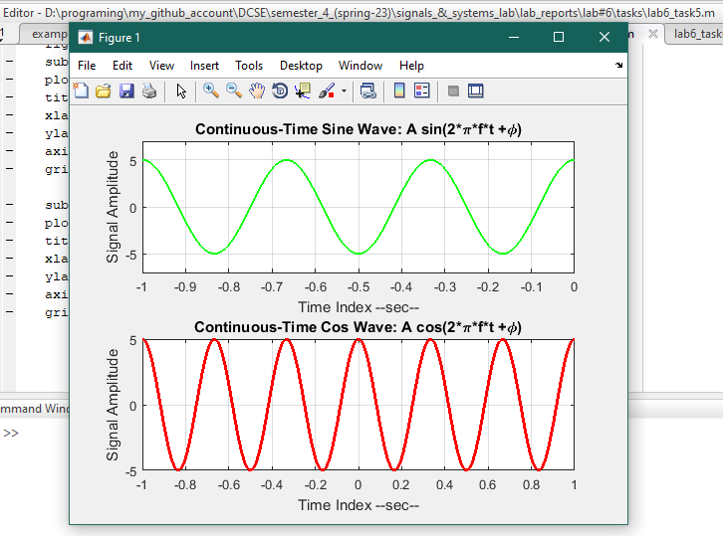

Task # 06:

Write a general program that takes ‘n’ sinusoids from user of same frequency, amplitude, and phase. Plot the individual sinusoids & the resultant using subplot function on same figure. Do perform proper labeling. Note: Take the amplitude, frequency, and phase given in example of case 1. Run the code for different values of n and state the result on paper.

Code:

clc;

clear;

close all;

amp = input('Enter Amplitude? ');

freq = input('Enter Frequency? ');

phase = input('Enter Phase? ');

time = -2 : 0.01: 2;

resultant = 0;

amount = input('How many signals are you plotting? ');

for i = 1 : amount

sig = amp * sin(2* pi * freq * time + phase);

resultant = resultant + sig;

figure(1)

subplot(amount+1,1,i)

plot(time,sig,'linewidth', 1.5)

title('Continuous-Time Sine Wave: Amp * sin(2*\pi*f*t +\phi)') ;

xlabel('Time Index --sec--')

ylabel('Signals Amplitude')

axis([time(1) time(end) -amp amp])

grid;

end

subplot(amount + 1,1, amount+1);

plot(time,resultant, 'g', 'linewidth', 1.5)

title('Continuous-Time Resultant Sine Wave: Amp * sin(2*\pi*f*t +\phi)') ;

xlabel('Time Index --sec--')

ylabel('Resultant Signals Amplitude')

grid

Output / Graphs / Plots / Results:

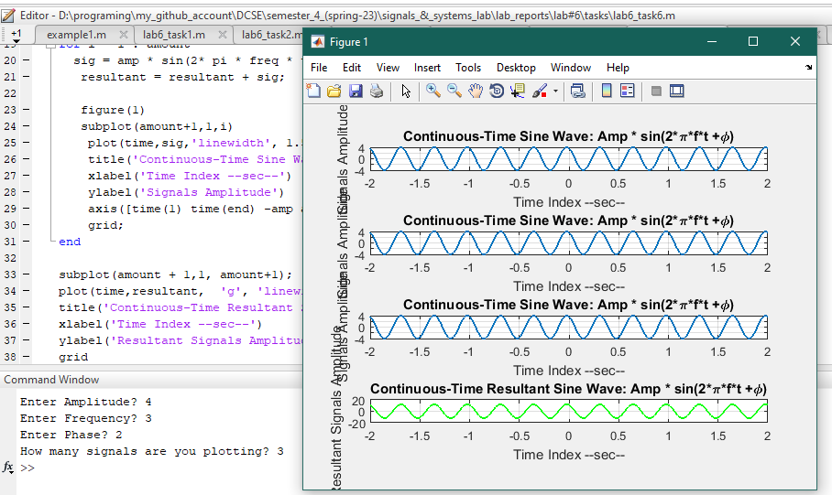

Task # 07:

Write a general program that takes ‘n’ sinusoids from user of same frequency and phase with varying amplitudes. Take amplitude from user on run time. Plot the individual sinusoids & the resultant using subplot function on same figure. Do perform proper labeling. Note: Take the amplitude and frequency given in example of case 2. Run the code for different values of n and state the result on paper.

Code:

clc;

clear;

close all;

amount = input('How many signals will you be plotting? ');

freq = 0.5;

time = -2: 0.01 : 2;

phase = 0;

resultant = 0;

for i = 1 : 1: amount

Amp = input('Enter amplitude for this signal? ');

sig = Amp * sin(2* pi * freq * time + phase);

resultant = resultant + sig;

figure(1)

subplot(amount +1,1,i);

plot(time,sig, 'm', 'linewidth', 1.5)

title('Continuous-Time Sine Wave: Amp * sin(2*\pi*f*t +\phi)') ;

xlabel('Time Index --sec--')

ylabel('Signals Amplitude')

axis([time(1) time(end) -Amp Amp])

grid;

end

subplot(amount + 1,1, amount+1);

plot(time,resultant, 'g', 'linewidth', 1.5)

title('Continuous-Time Resultant Sine Wave: Amp * sin(2*\pi*f*t +\phi)') ;

xlabel('Time Index --sec--')

ylabel('Resultant Signals Amplitude')

grid;

Output / Graphs / Plots / Results:

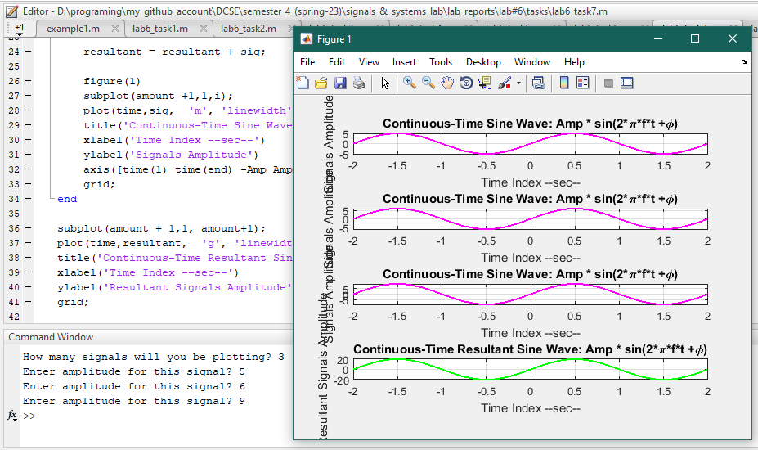

Task # 08:

Write a general program that takes ‘n’ sinusoids from user of same amplitude and phase with varying frequencies. Take each frequency from user on run time. Plot the individual sinusoids & the resultant using subplot function on same figure. Do perform proper labeling. Note: Take the amplitude and phase given in example of case 3. Run the code for different values of n and state the result on paper.

Code:

clc;

clear;

close all;

amount = input('How many signals will you be plotting? ');

Amp = 1;

time = -2: 0.01 : 2;

phase = 0;

resultant = 0;

for i = 1 : 1: amount

freq = input('Enter frequency of this signal? ');

sig = Amp * sin(2* pi * freq * time + phase);

resultant = resultant + sig;

figure(1)

subplot(amount+1,1,i)

plot(time,sig,'linewidth', 1.5)

title('Continuous-Time Sine Wave: Amp * sin(2*\pi*f*t +\phi)') ;

xlabel('Time Index --sec--')

ylabel('Signals Amplitude')

axis([time(1) time(end) -Amp Amp])

grid;

end

subplot(amount + 1,1, amount+1);

plot(time,resultant, 'g', 'linewidth', 1.5)

title('Continuous-Time Resultant Sine Wave: Amp * sin(2*\pi*f*t +\phi)') ;

xlabel('Time Index --sec--')

ylabel('Resultant Signals Amplitude')

grid

Output / Graphs / Plots / Results:

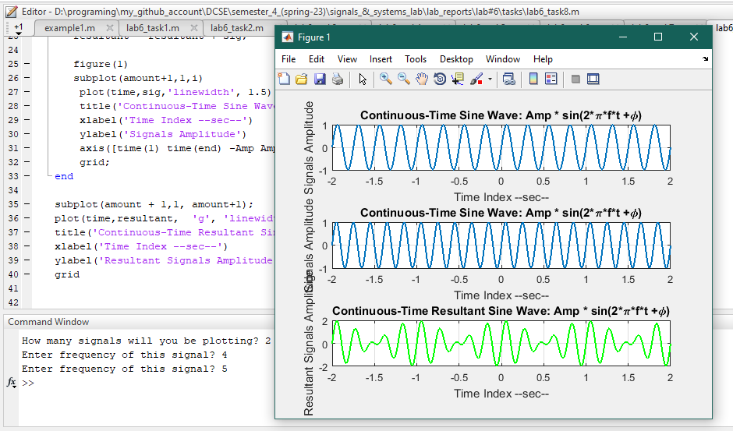

Task # 09:

Write a general program that takes ‘n’ sinusoids from user of same amplitude and frequency with varying phases. Take each phase from user on run time. Plot the individual sinusoids & the resultant using subplot function on same figure. Do perform proper labeling. Note: Take the amplitude and frequency given in example of case 4. Run the code for different values of n and state the result on paper.

Code:

clc;

clear;

close all;

amount = input('How many signals will you be plotting? ');

Amp = 1;

time = -2: 0.01 : 2;

freq = 0.5;

resultant = 0;

for i = 1 : 1: amount

phase = input('Enter phase of this signal? ');

sig = Amp * sin(2* pi * freq * time + phase);

resultant = resultant + sig;

figure(1)

subplot(amount+1,1,i)

plot(time,sig,'linewidth', 1.5)

title('Continuous-Time Sine Wave: Amp * sin(2*\pi*f*t +\phi)') ;

xlabel('Time Index --sec--')

ylabel('Signals Amplitude')

axis([time(1) time(end) -Amp Amp])

grid;

end

subplot(amount + 1,1, amount+1);

plot(time,resultant, 'g', 'linewidth', 1.5)

title('Continuous-Time Resultant Sine Wave: Amp * sin(2*\pi*f*t +\phi)') ;

xlabel('Time Index --sec--')

ylabel('Resultant Signals Amplitude')

grid

Output / Graphs / Plots / Results:

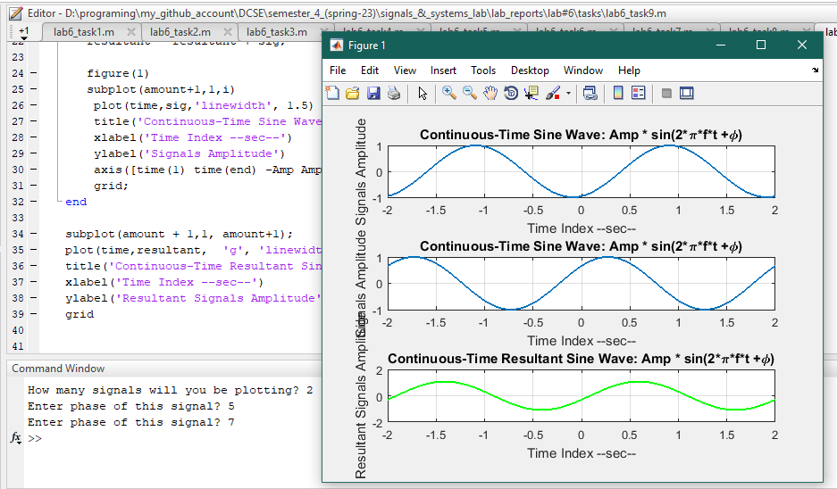

References:

To view my codes, please refer to my [GitHub Account](https://github.com/aimalexe/DCSE/tree/main/semester_4_(spring-23)/signals_%26_systems_lab/lab_reports).

Conclusion:

In this lab we have learnt how to plot and variant a sinusoid signal.

The End.